Contact: Anna Kayser FOR IMMEDIATE RELEASE
Email: Sept. 26, 2025
Phone:

New Look, Same Team: Indianapolis Indians Unveil New Team Logos
Indians new logos honor its baseball heritage and role as Indy’s original home sports team

INDIANAPOLIS – The Indianapolis Indians today unveiled new brand artwork honoring their proud history as the Circle City’s home for professional baseball since 1902. The new look pays homage to its early 1900s baseball heritage and the club’s role as Indy’s Original Home Team.

Centered around a bold, historic-inspired yet modernized “I”, the Indianapolis Indians’ new primary logo features the team name and founding year – 1902 – and is enclosed in a tribute to Native American ribbon work. The standalone Blackletter “I” and INDY Monogram will serve as the home hat logos, marking the fourth iteration of primary hat logos used by the organization since the early 1940s, following the Double II (1993-2025), Script I (1968-92) and Fishhook I (1944-67).

“The Indianapolis Indians have seen multiple iterations of brand identity made iconic by 12 championship seasons across our 124-year history,” said Randy Lewandowski, Indianapolis Indians president and CEO. “We’ve been a cornerstone of the Circle City community since 1902 and remain committed to continuing that tradition with outstanding fan experiences, affordable family entertainment, and operational success that contributes to the growth and vibrancy of Central Indiana.”

The following design choices were intentional in tying the future of the Indianapolis Indians with elements of familiarity, historical significance and excellence:

New Look:


Blackletter: Combined with baseball’s hand-drawn heritage in vintage lettering, the Blackletter “I” creates a visual bridge between two legacies that helped shape the identity of Indianapolis and baseball’s role in the city. The first baseball game played between two professional teams was held on May 4, 1871, in Fort Wayne, Ind. when the Fort Wayne Kekiongas – identified by a Blackletter “K” – defeated the Cleveland Forest Citys, 2-0.
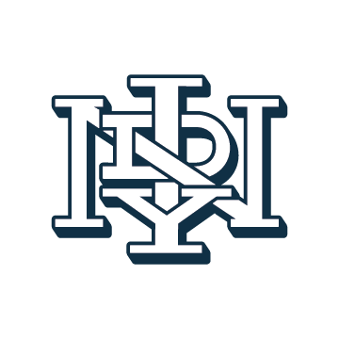
Monogram: The INDY monogram draws on traditional baseball design allowing for a compact, unique and easily remembered logo that evokes a classic, professional look similar to baseball clubs founded in the late 19th and early 20th centuries.
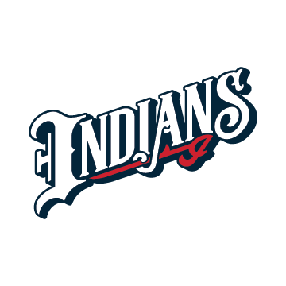
1980s Homage: The new Indians wordmark proudly displayed on home uniforms ties the letter with the name. At the end lies a Script “I”, the primary hat logo used by the team from 1968-92, as a tribute to the organization’s 1980s decade of excellence marked by five league championships.

Same Team:


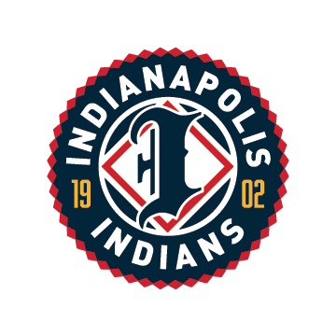
Indianapolis Indians: The team name, Indians, represents the proud heritage they share in this region. As announced in 2023, the team name will remain the “Indianapolis Indians” as the organization continues to partner with and learn from the Miami Nation of Indians of Indiana (MNI) and other experts to be the best stewards of the name.

Jerseys: The Indianapolis Indians will continue to wear white jerseys as their primary home uniform with red, Circle City and individual specialty jerseys as alternates. On the road, the Indians will wear gray jerseys with an “INDPLS” wordmark.

Colors: While Wrought Iron Blue (navy) is our foundation as a primary color, Scarlet (red)
continues to be a staple of the Indians color palette as an accent. Gold also remains in all
variation of the primary logo and on red jerseys, representing excellence and heritage.

“As we approach the 30th anniversary of Victory Field’s opening at the corner of West and Maryland, the Indianapolis Indians are eager to continue a tradition of providing the Indianapolis community with a gathering place and affordable, family-friendly entertainment year-round,” said Bruce Schumacher, chairman of the Indianapolis Indians board of directors.

Throughout three years of research, design and implementation, the Indianapolis Indians:

- Compiled 125 hours of interviews with fans, community leaders, front office personnel, board members, season ticket holders, MiLB executives and representatives from the Miami Nation of Indians of Indiana.
- Conducted three large, comprehensive gallery sessions along with 10-plus individual sessions with community leaders and board members, directly leading to the development of approximately 30 iterations of color palettes, logos, primary logos and jersey designs.

For more information, please visit IndysOriginalHomeTeam.com.

About the Indianapolis Indians
The Indianapolis Indians are the professional Triple-A baseball club affiliate of the Pittsburgh Pirates. In continuous operation since 1902, the organization believes in creating affordable and memorable experiences for fans so they can grow closer together with family, friends, and the community through the game of baseball. The Indians play their home games at Victory Field, a 13,750-seat ballpark located in downtown Indianapolis and White River State Park. The venue opened in 1996 and has received numerous national accolades as one of the best minor league ballparks in the United States. The team has led Minor League Baseball in combined total attendance over the past 15 seasons. In 2018, the organization was recognized as Ballpark Digest Team of the Year. It was also named a 2019 Best Places to Work by the Indiana Chamber of Commerce.

